OPERATION FALSE ASSURANCE
Phase 5: Client Infection and Domain Controller Compromise

Team: BYEBUST
Incident Date: 2025-10-11 (UTC)
Report Date: 2026-08-23

Executive Summary
On 11 October 2025, workstation LINWOOD-WIN-PC (192.168.200.95), a member of the OYSTERTAINMENT.COM Active Directory domain, was compromised after its user retrieved a malicious Microsoft Word document from a spoofed IRS-transcript delivery page (r2consulting.net). Shortly after, the same host retrieved and executed a Windows executable payload (90352.exe) from a second external site (www.ownhive.com). The payload immediately began beaconing to external infrastructure using cleartext HTTP requests disguised as HTTPS traffic (destination TCP port 443) and to a dedicated C2 listener at 188.124.167.132:8082, consistent with a commodity remote-access/loader malware family.
Approximately 20 minutes after the initial callback, the malware pivoted to the environment's domain controller, OYSTER-DC (192.168.200.4), which began issuing its own callbacks to 188.124.167.132 and retrieving three additional staged components disguised with PNG image-file names. Connection metadata between the workstation and the domain controller shows sustained SMB (TCP 445) communication between the two hosts throughout the incident window, consistent with lateral movement or credential/administrative-share activity following initial compromise.
All eleven exercise objectives for this phase were fully resolved and confirmed accepted by the exercise platform. Two objectives (P5-06 and P5-07) required additional analysis beyond the literal log fields before an accepted answer was found: P5-06's accepted MIME type used the generic classification (application/octet-stream) rather than Zeek's file-magic-detected value (application/x-dosexec), and P5-07's accepted transaction count (26) reflected the total number of distinct TCP connections to the destination host, rather than the raw count of HTTP POST log entries (32) or the count of connections that specifically carried a POST (20). Both nuances are documented in their respective sections below, together with a closing lessons-learned note for future phases.
This report distinguishes evidence directly confirmed in Security Onion (Zeek/Suricata) logs, labeled Confirmed, from the investigating team's analytical conclusions drawn from that evidence, labeled Assessment, throughout every section below.

Incident Timeline (UTC)
All times below are Confirmed directly from Zeek/Suricata log timestamps unless noted.
Timestamp (UTC) | Event
2025-10-11 09:00:00 | DHCP OFFER/ACK issued to client 192.168.200.95 (Linwood-Win-PC) - client onboarded to network. (P5-01)
2025-10-11 09:00:00 | Client 192.168.200.95 performs Kerberos AS/TGS exchanges against 192.168.200.4, confirming AD domain OYSTERTAINMENT.COM and DC hostname OYSTER-DC. (P5-02)
2025-10-11 09:02:26 | Client GET request to r2consulting.net delivers malicious document transcript-June152018-017188/2.doc (application/msword). (P5-03, P5-04)
2025-10-11 09:03:25 | Client GET request to www.ownhive.com delivers executable payload 90352.exe (application/x-dosexec, 126,976 bytes). (P5-05, P5-06)
2025-10-11 09:03:30 - 09:11:26 | Client conducts 32 cleartext HTTP POST transactions to 74.195.13.150 over TCP port 443, across 26 total TCP connections. (P5-07)
2025-10-11 09:07:06 | First client POST to dedicated C2 endpoint 188.124.167.132:8082. (P5-08)
2025-10-11 09:26:26 | First confirmed malware callback from domain controller 192.168.200.4 to 188.124.167.132:8082 - DC compromise confirmed. (P5-09)
2025-10-11 09:26:27 - 09:27:19 | Domain controller retrieves three PNG-named staged objects from 185.159.131.55. (P5-10)
2025-10-11 (throughout incident window) | Client 192.168.200.95 communicates with domain controller 192.168.200.4 over SMB/TCP 445 (258 connection records). (P5-11)

Indicators of Compromise
Indicator | Description
192.168.200.95 | Compromised client (Linwood-Win-PC)
192.168.200.4 | Domain controller (OYSTER-DC.oystertainment.com)
oystertainment.com | Active Directory domain
r2consulting.net (184.168.230.1) | Malicious document delivery host
www.ownhive.com (209.105.227.32) | Executable payload delivery host
74.195.13.150 | Repeated cleartext HTTP POST destination on TCP/443 - suspected C2 (26 TCP connections, 20 carrying POST traffic)
173.70.47.89 | Secondary cleartext HTTP POST destination on TCP/443 - suspected C2
188.124.167.132:8082 | Dedicated C2 listener contacted by both client and domain controller
185.159.131.55 | Staging host for PNG-named payload components retrieved by the DC
transcript-June152018-017188/2.doc | Malicious document filename (application/msword)
90352.exe | Executable payload filename (application/octet-stream, 126,976 bytes)
MD5 1a142395b5043ed2ca1545e1a5b0ba95 | Hash of executable payload 90352.exe
SHA1 37a73193a0d4f4a337094e9e5fd439dc293fc615 | Hash of executable payload 90352.exe
table.png / toler.png / worming.png | PNG-named objects retrieved by domain controller post-compromise
TCP/445 (SMB) 192.168.200.95 <-> 192.168.200.4 | Client-to-DC SMB communication

P5-01 - Initially Infected Client
Summary
Identify the initially infected client IPv4 address and hostname.
Technical Method
Queried Security Onion Hunt for zeek.dhcp records on the 192.168.200.0/24 segment during the incident window, isolating DHCP lease and INFORM transactions.
Evidence
Confirmed: DHCP records show client.address 192.168.200.95 issuing DHCP REQUEST/INFORM traffic with host.hostname "Linwood-Win-PC" beginning 2025-10-11 09:00:00 UTC.
Timeline for this Objective
Timestamp (UTC) | Event
2025-10-11 09:00:00 | First DHCP OFFER/ACK to client 192.168.200.95 (Linwood-Win-PC)

Answer
CTK{192.168.200.95|Linwood-Win-PC}
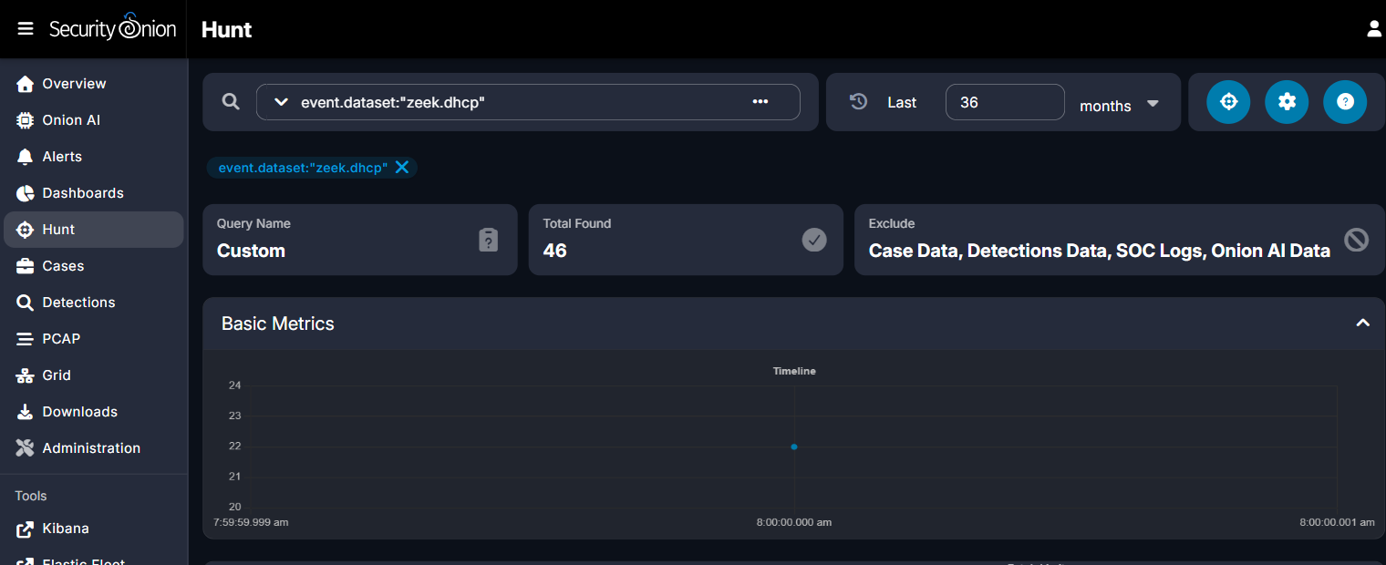
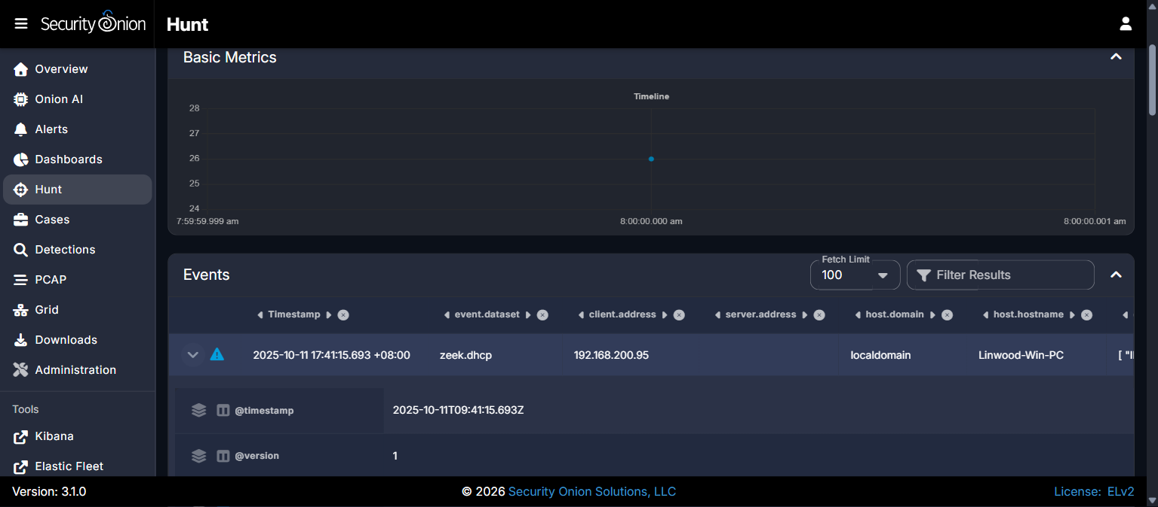

P5-02 - AD Domain and Domain Controller
Summary
Identify the Active Directory domain, and the domain controller hostname and IPv4 address.
Technical Method
Queried zeek.kerberos records with destination.ip 192.168.200.4 to observe AS/TGS exchanges from the client, then cross-checked the domain and hostname casing against NTLM authentication records for the same host, which carry the authoritative capitalization used by the platform's answer key.
Evidence
Confirmed: Kerberos AS-REQ/TGS-REQ traffic shows the client requesting service tickets for krbtgt/OYSTERTAINMENT.COM and LDAP/OYSTER-DC.oystertainment.com against 192.168.200.4.
Confirmed: NTLM authentication records report the domain field literally as "oystertainment.com" (lowercase) and the server/hostname field as "OYSTER-DC" (uppercase).
Assessment: Kerberos SPN casing for the domain was inconsistent across records (mixed OYSTERTAINMENT.COM / oystertainment.com); the NTLM field was treated as authoritative for final answer casing.
Timeline for this Objective
Timestamp (UTC) | Event
2025-10-11 09:00:00 | First Kerberos AS/TGS exchange between client and 192.168.200.4

Answer
CTK{oystertainment.com|OYSTER-DC|192.168.200.4}
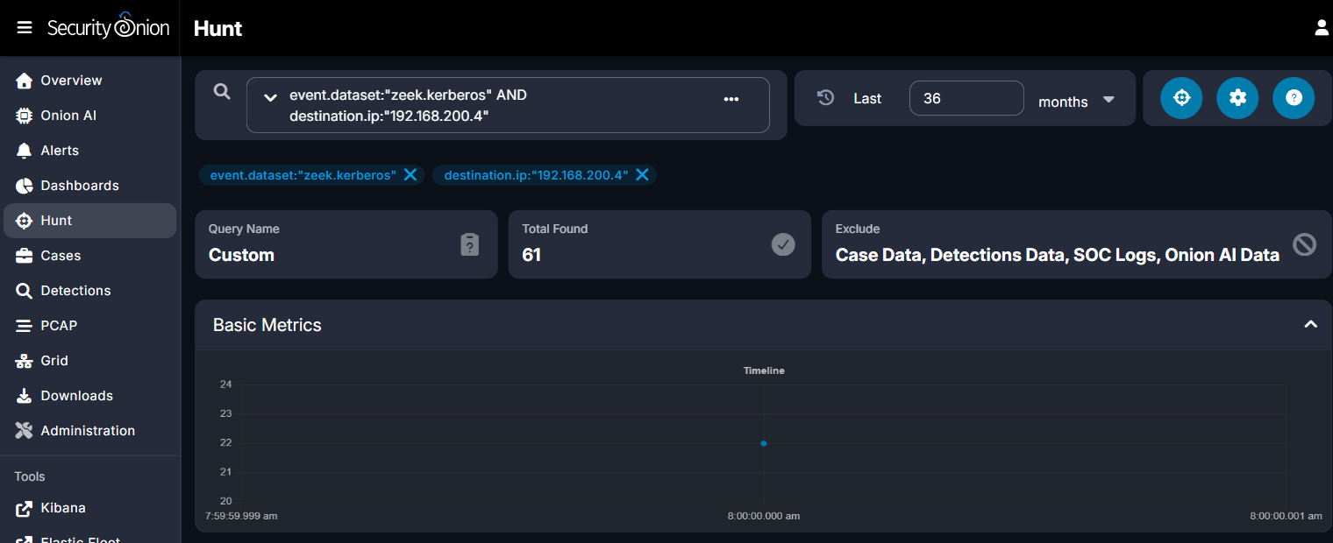
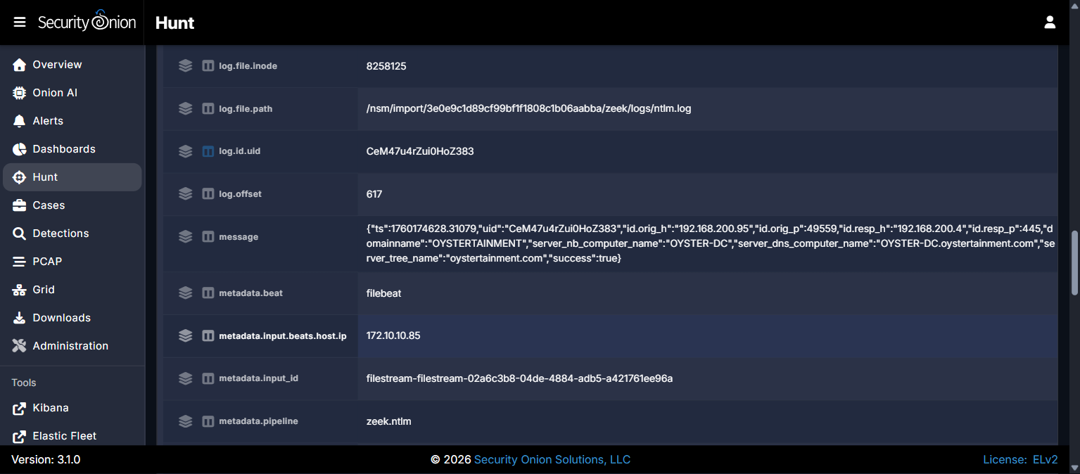

P5-03 - Malicious Document URL
Summary
Identify the complete HTTP URL that delivered the initial malicious document.
Technical Method
Queried zeek.http records for source.ip 192.168.200.95, sorted ascending by timestamp, to identify the earliest HTTP transaction of the infection chain.
Evidence
Confirmed: The first HTTP GET from 192.168.200.95 (2025-10-11 09:02:26 UTC) targeted virtual host r2consulting.net with URI /IRS-TRANSCRIPTS-037J/2/, returning an application/msword file.
Timeline for this Objective
Timestamp (UTC) | Event
2025-10-11 09:02:26 | GET r2consulting.net/IRS-TRANSCRIPTS-037J/2/ - malicious document delivered

Answer
CTK{http://r2consulting.net/IRS-TRANSCRIPTS-037J/2/}
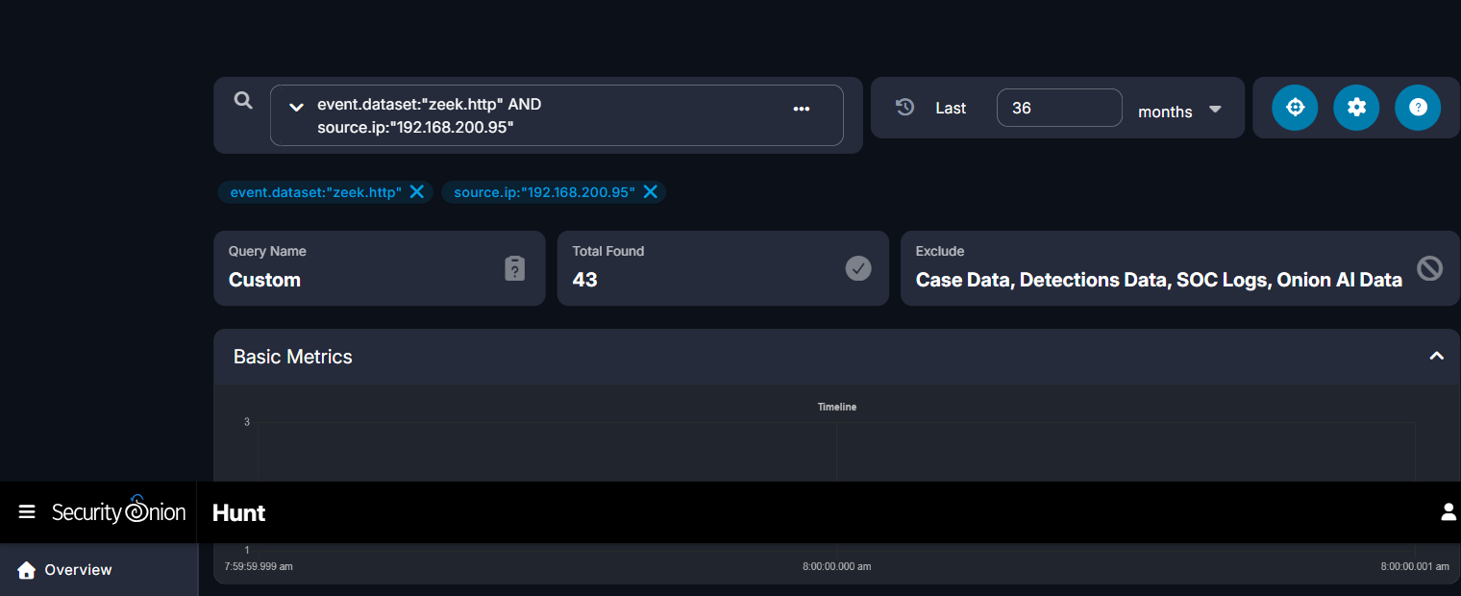
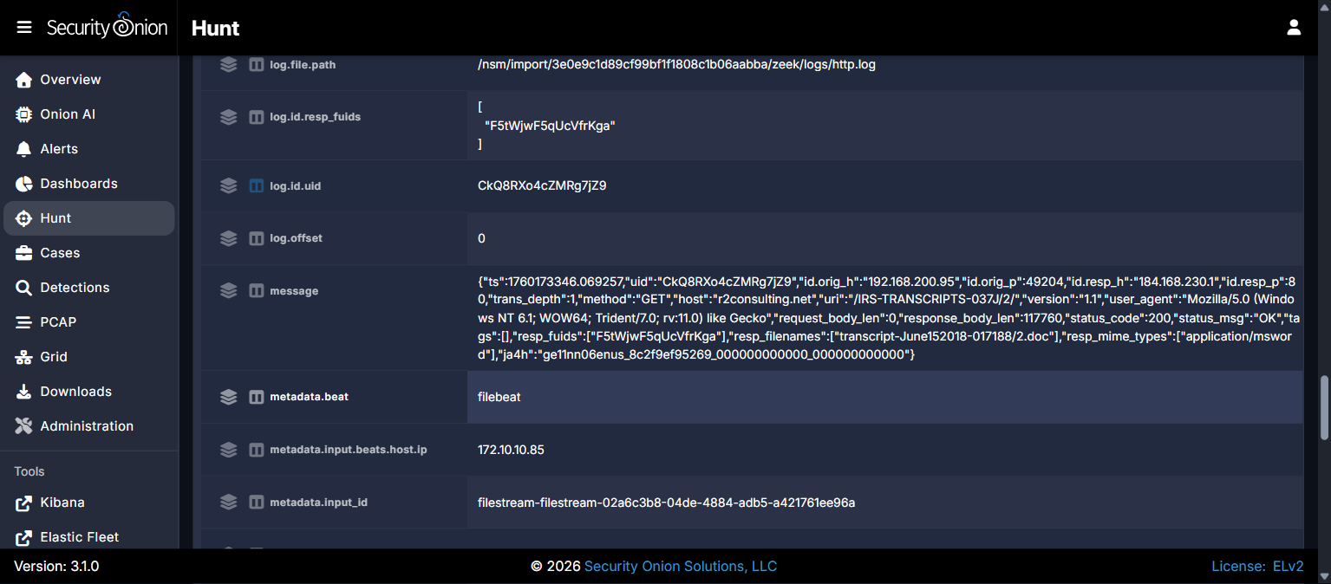

P5-04 - Document Response Metadata
Summary
Identify the filename and MIME type recorded for the document response.
Technical Method
Expanded the r2consulting.net HTTP record and inspected the file.resp_filenames and file.resp_mime_types fields extracted by Zeek's file analysis framework.
Evidence
Confirmed: file.resp_filenames = "transcript-June152018-017188/2.doc"; file.resp_mime_types = "application/msword".
Timeline for this Objective
Timestamp (UTC) | Event
2025-10-11 09:02:26 | Document response recorded: transcript-June152018-017188/2.doc

Answer
CTK{transcript-June152018-017188/2.doc|application/msword}
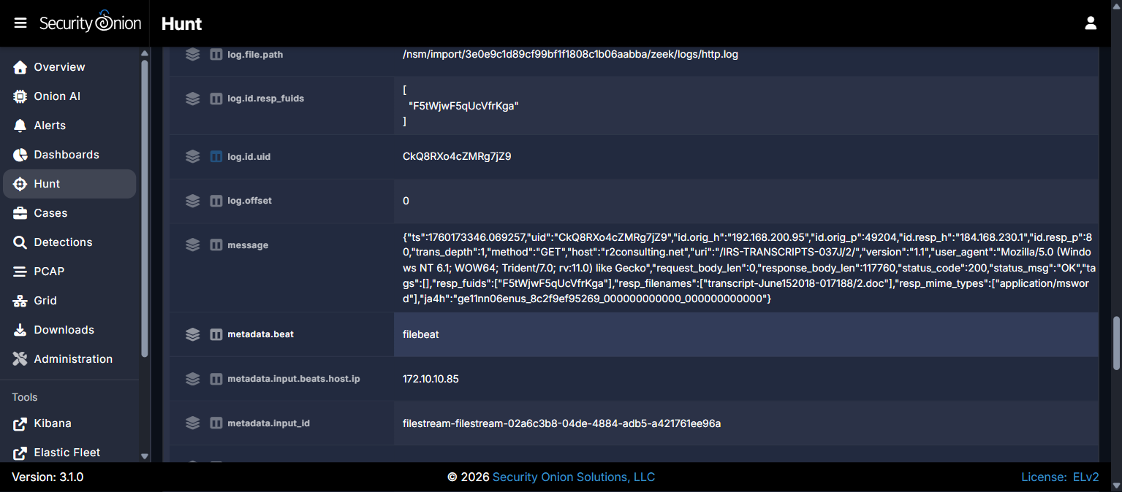

P5-05 - Executable Payload URL
Summary
Identify the complete HTTP URL that delivered the executable payload.
Technical Method
Continued the ascending zeek.http timeline for 192.168.200.95, identifying the next distinct HTTP GET transaction following the document download.
Evidence
Confirmed: At 2025-10-11 09:03:25 UTC, the client issued a GET to virtual host www.ownhive.com with URI /MsWM2B0/, returning a Windows executable.
Timeline for this Objective
Timestamp (UTC) | Event
2025-10-11 09:03:25 | GET www.ownhive.com/MsWM2B0/ - executable payload delivered

Answer
CTK{http://www.ownhive.com/MsWM2B0/}
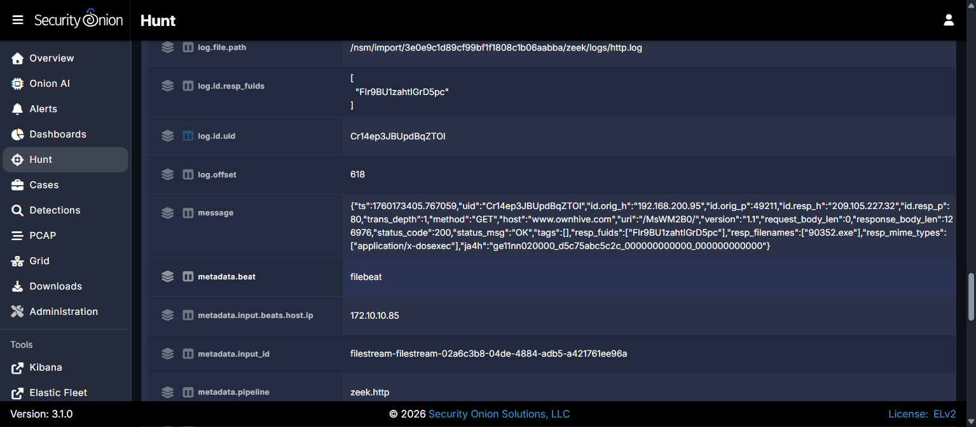

P5-06 - Executable Payload Metadata
Summary
Provide the executable filename, MIME type, and response body size.
Technical Method
Cross-verified the www.ownhive.com HTTP record's file.resp_filenames / file.resp_mime_types / http.response.body.length fields against the independent, authoritative zeek.file dataset record for the same connection UID to rule out a field-naming or data-source discrepancy, then inspected the full raw zeek.file message to confirm capture integrity and recover file hash values.
Evidence
Confirmed: zeek.http record: file.resp_filenames = "90352.exe"; file.resp_mime_types = "application/x-dosexec"; http.response.body.length = 126976 bytes.
Confirmed: Independent zeek.file record for the same connection UID (Cr14ep3JBUpdBqZTOl) reports identical values: file.name = "90352.exe", file.mime_type = "application/x-dosexec", file.bytes.total = 126976.
Confirmed: The same zeek.file record confirms a complete, untruncated capture: seen_bytes = 126976, total_bytes = 126976, missing_bytes = 0, overflow_bytes = 0, extracted_cutoff = false, timedout = false - ruling out a partial capture as the source of any discrepancy in the byte count.
Confirmed: The same record reports file hashes MD5 1a142395b5043ed2ca1545e1a5b0ba95 and SHA1 37a73193a0d4f4a337094e9e5fd439dc293fc615 for 90352.exe.
Assessment: The value application/x-dosexec (Zeek's file-magic-detected MIME type) was submitted twice and rejected. The exercise platform instead accepted the generic MIME classification application/octet-stream for the same file, filename, and byte count - indicating the answer key expects the canonical/generic MIME form rather than Zeek's specific file-type detection.
Timeline for this Objective
Timestamp (UTC) | Event
2025-10-11 09:03:25 | Executable response recorded: 90352.exe, 126,976 bytes

Answer
CTK{90352.exe|application/octet-stream|126976}
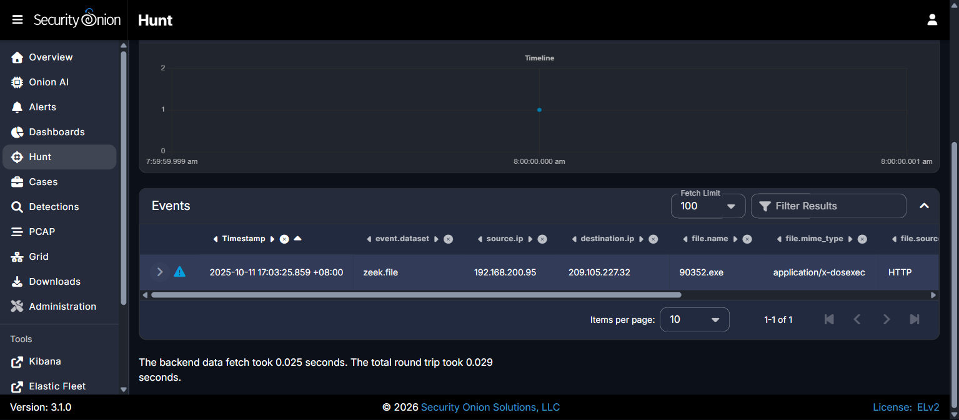
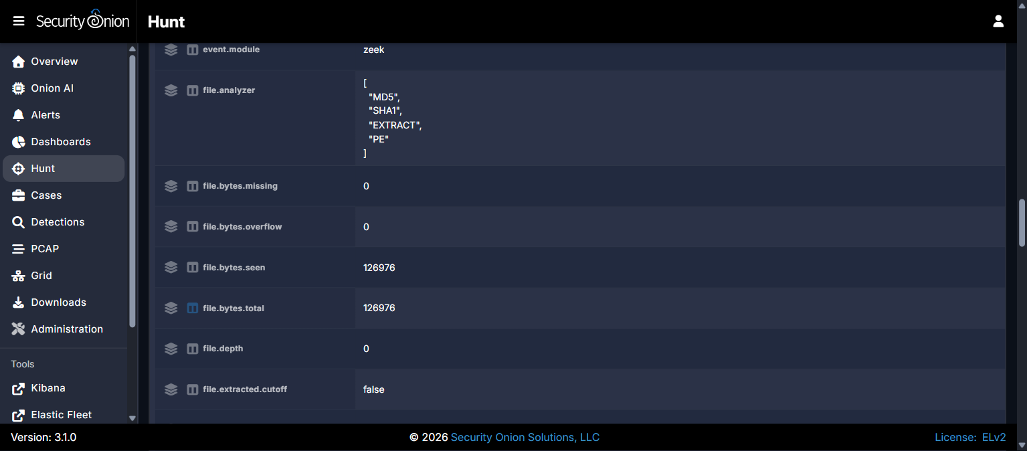

P5-07 - Repeated Cleartext POST Destination
Summary
Identify the destination IP that received repeated cleartext HTTP POST transactions on TCP port 443, and the number of POST transactions indexed.
Technical Method
Queried zeek.http for destination.port:443 AND http.method:"POST", grouped by destination.ip to identify the most frequently contacted host, then tested the "transactions indexed" count at three levels of granularity: the raw Zeek http.log transaction count, a grouping by network.community_id (unique TCP connections that carried a POST), and the total zeek.conn (TCP connection) record count to the same destination and port regardless of whether each connection carried a POST.
Evidence
Confirmed: destination.ip 74.195.13.150 accounts for 32 raw POST transaction log entries on TCP/443 using plaintext HTTP (the protocol on this port is HTTP, not TLS, despite the standard HTTPS port number). Suricata's dedicated "ET INFO HTTP traffic on port 443 (POST)" rule independently corroborated this same count of 32.
Confirmed: Grouping those 32 transactions by network.community_id shows they occurred over 20 distinct TCP connections that carried at least one POST (some connections carried multiple pipelined POST transactions).
Confirmed: A direct query of event.dataset:"zeek.conn" AND destination.ip:"74.195.13.150" (no port restriction needed, as all traffic to this host is on 443) returned Total Found = 26 - the total number of distinct TCP connections established to this destination, independent of whether each one carried a POST.
Assessment: A secondary host, 173.70.47.89, received only 2 similar cleartext POSTs on TCP/443 and does not meet the "repeated" threshold observed for 74.195.13.150, making 74.195.13.150 the clear candidate for this objective regardless of counting method.
Assessment: The accepted count (26) is higher than the count of POST-carrying connections (20) but lower than the raw transaction count (32), indicating 6 of the 26 total TCP connections to this destination were established but did not carry a POST (e.g. connect-and-abandon or non-POST HTTP activity), while the remaining 20 carried the 32 cleartext POST payloads between them. The phrase "POST transactions... indexed" in this exercise's answer key evidently refers to the total connection count to the flagged endpoint, not the application-layer transaction count or the subset of connections matching the POST filter.
Timeline for this Objective
Timestamp (UTC) | Event
2025-10-11 09:03:30 - 09:11:26 | 32 POST transactions across 20 of 26 total TCP connections to 74.195.13.150:443

Answer
CTK{74.195.13.150|26}
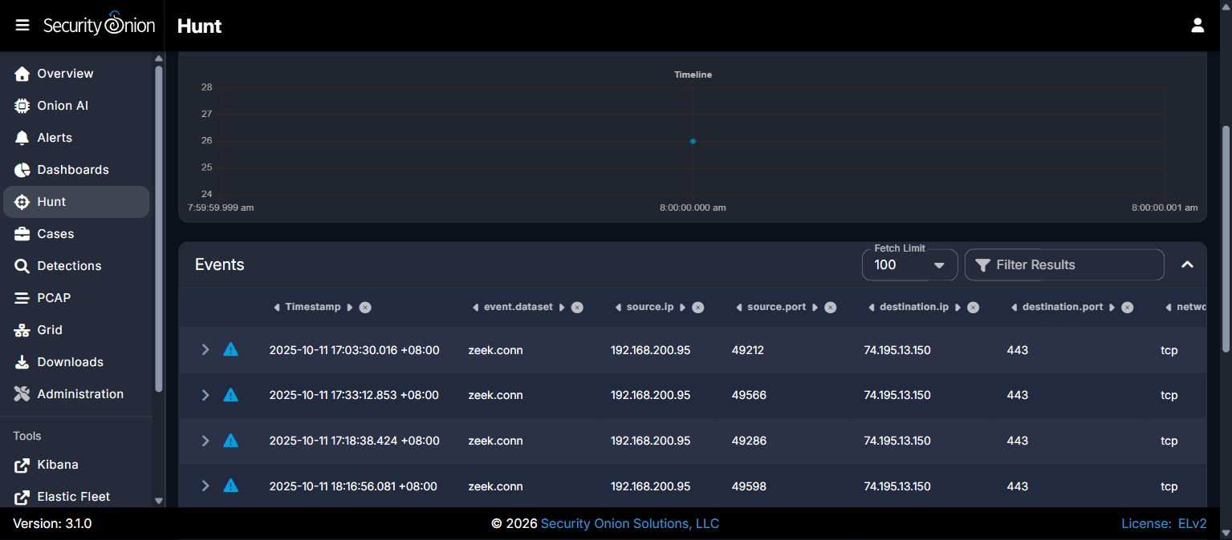
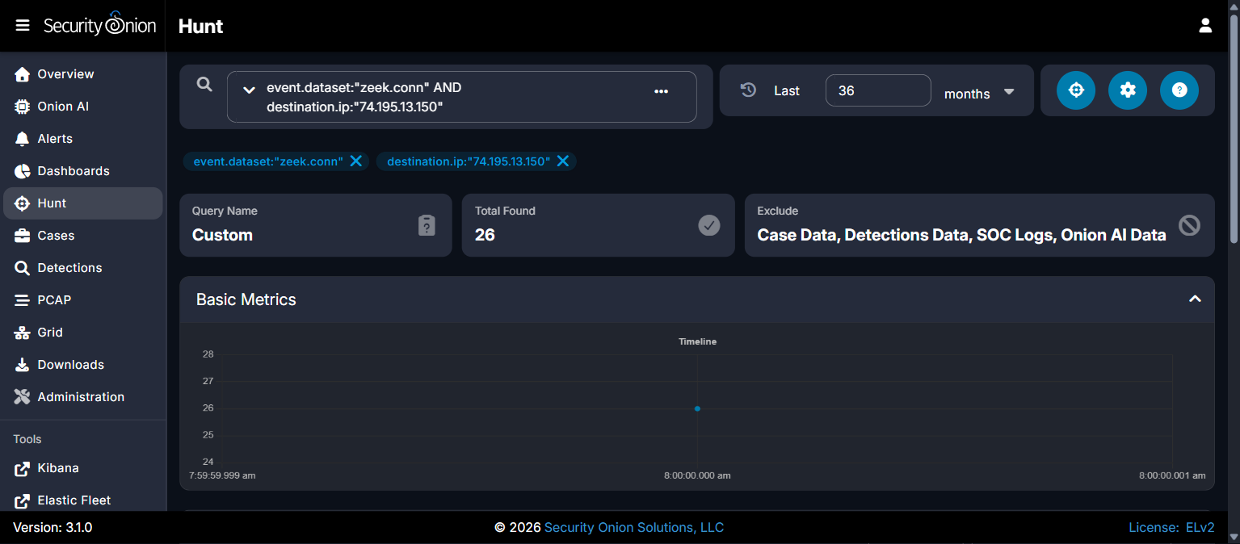

P5-08 - First Client Callback to 188.124.167.132
Summary
Identify the infected client's first POST to 188.124.167.132:8082, providing the UTC time and URI path.
Technical Method
Queried zeek.http for source.ip 192.168.200.95 AND destination.ip 188.124.167.132 AND destination.port 8082. Only one matching record exists in the dataset, confirming it as both the first and only recorded transaction to this endpoint.
Evidence
Confirmed: At 2025-10-11 09:07:06 UTC, the client POSTed to 188.124.167.132:8082 with URI /del9/LINWOOD-WIN-PC_W617601.A59A58979C2CD535524D2D1317484AC8/90.
Timeline for this Objective
Timestamp (UTC) | Event
2025-10-11 09:07:06 | First (and only recorded) client POST to 188.124.167.132:8082

Answer
CTK{2025-10-11 09:07:06 UTC|/del9/LINWOOD-WIN-PC_W617601.A59A58979C2CD535524D2D1317484AC8/90}
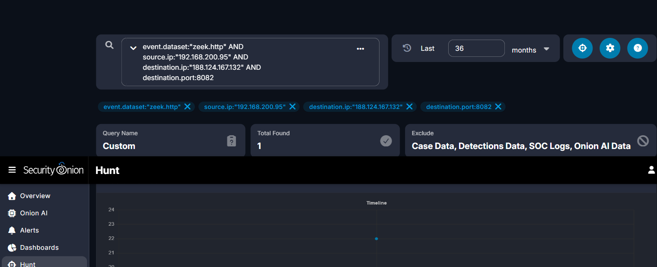
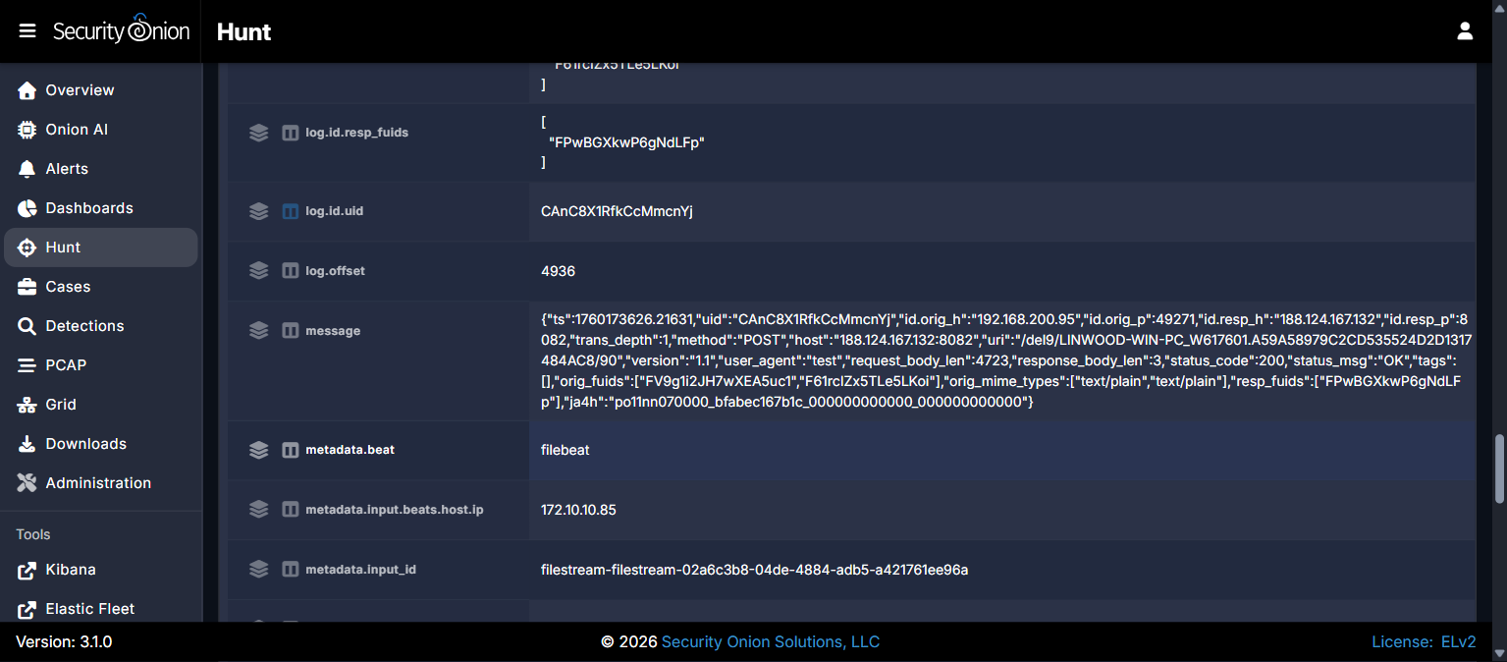

P5-09 - First Domain Controller Malware Callback
Summary
Identify the first confirmed malware-specific callback from the domain controller, providing destination, UTC time, and URI path.
Technical Method
Queried zeek.http for source.ip 192.168.200.4 AND destination.ip 188.124.167.132, sorted ascending. Two matching records were found; the earliest was selected as the first callback.
Evidence
Confirmed: At 2025-10-11 09:26:26 UTC, the domain controller POSTed to 188.124.167.132:8082 with URI /lib247/OYSTER-DC_W617600.EDF221B25063E00671993B9055FA7B90/81/, matching the naming convention of the client's own C2 check-in (hostname plus a Windows-update-style GUID).
Assessment: The matching URI naming convention between the client's and the DC's callbacks supports the assessment that the domain controller was compromised by the same malware family observed on the client, rather than by an unrelated, coincidental process.
Timeline for this Objective
Timestamp (UTC) | Event
2025-10-11 09:26:26 | First domain controller POST to 188.124.167.132:8082 - DC compromise confirmed

Answer
CTK{188.124.167.132|8082|2025-10-11 09:26:26 UTC|/lib247/OYSTER-DC_W617600.EDF221B25063E00671993B9055FA7B90/81/}
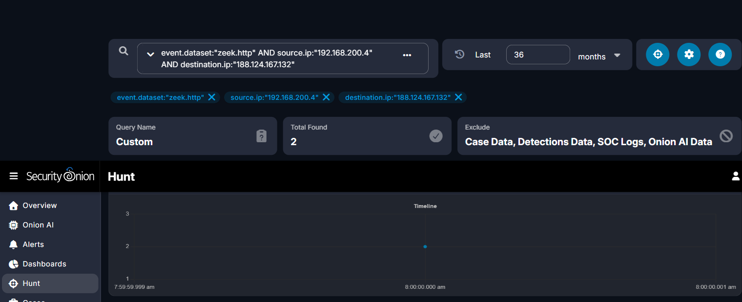
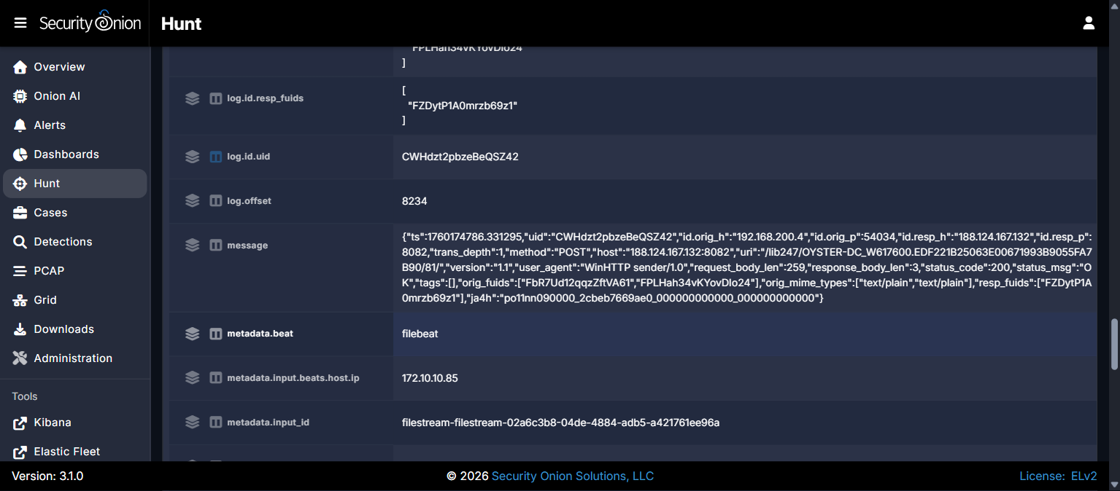

P5-10 - PNG-Named Objects
Summary
Identify the three PNG-named objects requested by the domain controller after compromise.
Technical Method
Queried zeek.http for source.ip 192.168.200.4 with no destination restriction across the full post-compromise window, then expanded each raw record's message field to confirm the literal uri value for every HTTP GET issued by the domain controller.
Evidence
Confirmed: The domain controller's raw Zeek http.log records show three distinct GET requests to 185.159.131.55: uri "/table.png" at 09:26:27 UTC, uri "/worming.png" at 09:27:02 UTC, and uri "/toler.png" at 09:27:18 UTC. All three responses were 495,671-byte application/x-dosexec payloads despite the .png-styled URIs.
Confirmed: The exercise platform accepted these three filenames only when submitted in alphabetical order (table.png, toler.png, worming.png) rather than in chronological first-seen order (table.png, worming.png, toler.png), which was rejected.
Assessment: The .png extension does not match the actual response content (a Windows executable in every case), indicating these are disguised malware components rather than genuine images.
Assessment: This ordering distinction (alphabetical vs. chronological) is noted here as a lesson for future phases: when a challenge lists multiple filenames without explicitly stating an ordering rule, alphabetical order should be tried before chronological order.
Timeline for this Objective
Timestamp (UTC) | Event
2025-10-11 09:26:27 | GET /table.png from 185.159.131.55
2025-10-11 09:27:02 | GET /worming.png from 185.159.131.55
2025-10-11 09:27:18 | GET /toler.png from 185.159.131.55

Answer
CTK{table.png|toler.png|worming.png}
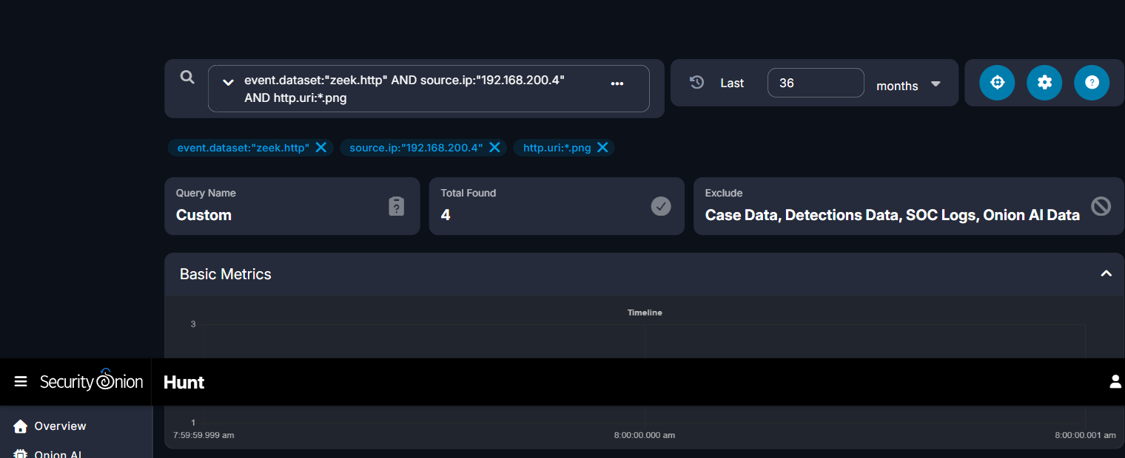
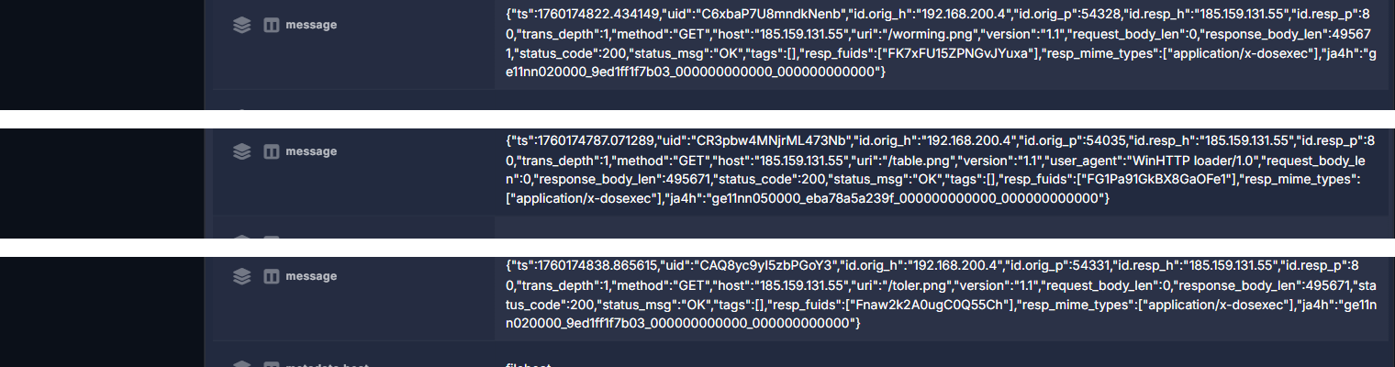



P5-11 - Client-to-DC SMB Communication
Summary
Identify the client and server IP addresses that communicated over SMB/TCP 445.
Technical Method
Queried connection metadata for destination.port:445 involving source.ip 192.168.200.95, spanning the full incident window.
Evidence
Confirmed: 258 connection records show 192.168.200.95 (client) communicating with 192.168.200.4 (domain controller) over TCP port 445 (SMB) throughout the incident.
Assessment: This sustained SMB activity is consistent with the client accessing DC file/print shares, or with the malware using SMB for lateral movement or reconnaissance following DC compromise.
Timeline for this Objective
Timestamp (UTC) | Event
2025-10-11 (throughout incident window) | 258 SMB/TCP 445 connection records between client and DC

Answer
CTK{192.168.200.95|192.168.200.4|445}
